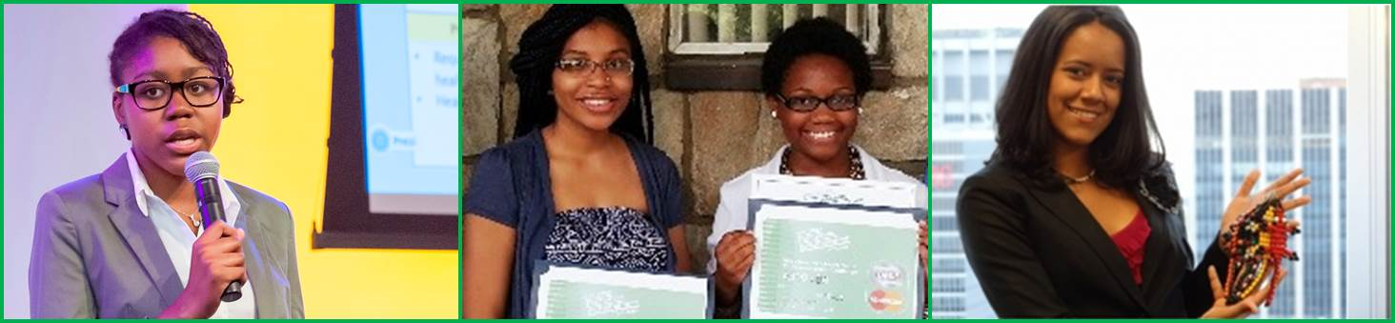

NFTE Global Girls Entrepreneurship Tech BizCamp

BizCamp Program Overview

Are you a female student interested in learning…
- How to start your own business?
- How to make technology work for your business?
- How to be your own boss?

Become a FEMALE ENTREPRENEUR by joining NFTE’s Summer BizCamp® TODAY!
NFTE DC Region’s Global Girls Entrepreneurship Tech BizCamp offers female students the opportunity to learn a tech-infused NFTE Entrepreneurship curriculum in a highly interactive and intensive 2-week camp setting. Through field trips, guest speakers, industry exposure, and engaging activities, participants learn the basics of putting together a business plan including technological platforms while also developing valuable academic and life skills.

BizCamp Dates

- When: July 6-17, 2015 (Monday – Friday) , 9:00am – 4:00pm, daily
- Where: Howard University, School of Engineering
BizCamp Model

Days 1-7 | Days 8-9 | Day 10
Accelerated Learning  Through experiential learning, tech-based work time, and guest speakers, students take a deep dive into the world of tech-infused entrepreneurship and learn what it takes to start their own business. | Coaching Sessions  Students work with volunteer business plan coaches to refine their business ideas and hone their presentation skills in preparation for the final Business Plan Competition. | Business Plan Competition  At the end of this 2 week camp, all participants present their business ideas in front of a panel of judges while competing for cash prizes (top three winners).

Applications due by Friday, June 12, 2015 !
ALL CAMP EXPENSES PAID BY NFTE AND SPONSORS

www.nfte.com

